Tia Noel
Final Project Proposal:
Name: GigGoals
Description: GigGoals is a full-stack MERN job application tracker. Users can register and log in securely, create “Gigs” (job opportunities) as projects, and track application steps as tasks with statuses (To Do, In Progress, Done). All routes are protected with JWT authentication and strict ownership-based authorization, so users can only access and modify their own gigs and tasks.
Route Tree:
Auth Routes :
Authorization Rule
Only the authenticated user who owns a Gig may view, create, update, or delete that gig and its associated tasks.
URL | HTTP VERB | ACTION
api/auth/register | POST | register
api/auth/login | POST | login
api/auth/me | GET | current user
Gigs (Projects)
URL | HTTP VERB | ACTION
api/gigs | GET | index
api/gigs/:gigId | GET | show
api/gigs | POST | create
api/gigs/:gigId | PUT / PATCH | update
api/gigs/:gigId | DELETE | destroy
Tasks
URL | HTTP Verb | ACTION
api/gigs/:gigId/tasks | GET | index
api/gigs/:gigId/tasks/:taskId | GET | show
api/gigs/:gigId/tasks | POST | create
api/gigs/:gigId/tasks/:taskId | PUT / PATCH | update
api/gigs/:gigId/tasks/:taskId | DELETE | destroy

Timeline:
- 2/5 – Planning complete (route tree, ERD, wireframes, repos ready)
- 2/6 – Backend foundation: Express + Mongo + auth
- 2/7 – Gigs CRUD + ownership authorization
- 2/8 – Tasks nested CRUD + ownership authorization + Postman testing
- 2/9 – Frontend setup: routing + AuthContext + protected routes
- 2/10 – Dashboard + Gig Details UI + CRUD + loading/error states
- 2/11 – Deploy backend + frontend (Render) + env/CORS
- 2/12 – README + final test + presentation prep
Please see other attachments: ERD image (PNG)/ Wireframe images
Wire Frame:
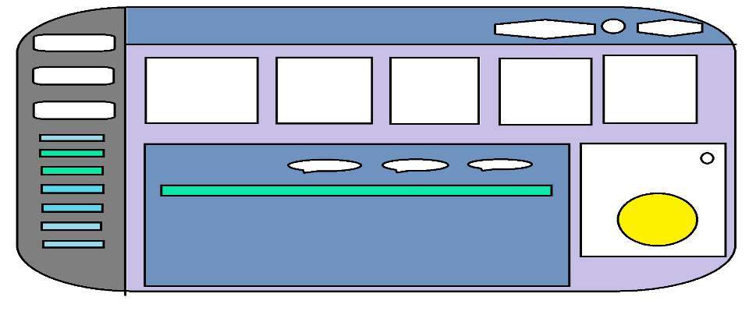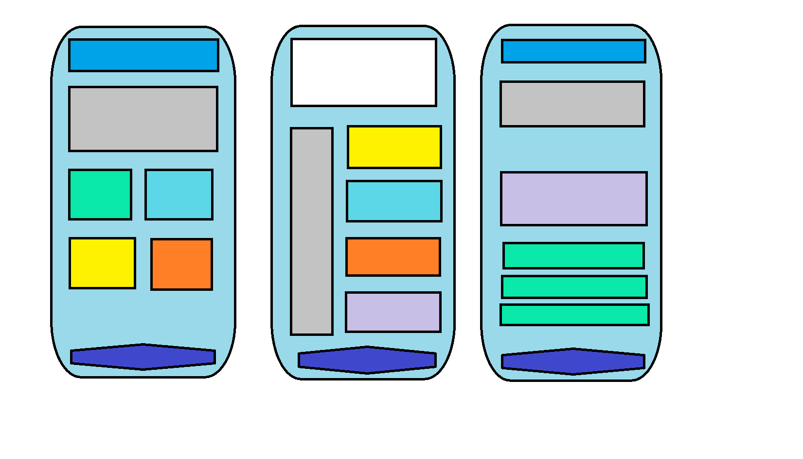
ERD image:
